THE MODELS.PY AND ITS FUNCTION
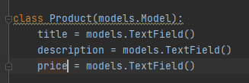

Note you must let django knows about the app you created in which all these file are embedded in them in the settings.py. so you register it there. The name of this app was firstApp. See below for clarification. You should put it in the installed app
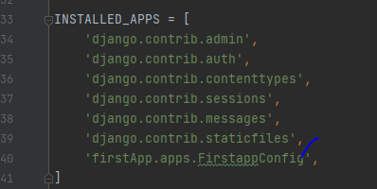

This will create a database table of textfield in which you can add long text maybe story to your table. After creating this class in the models.py you need to register it in the admin.py see below

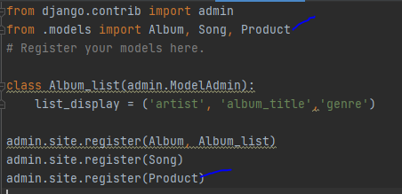

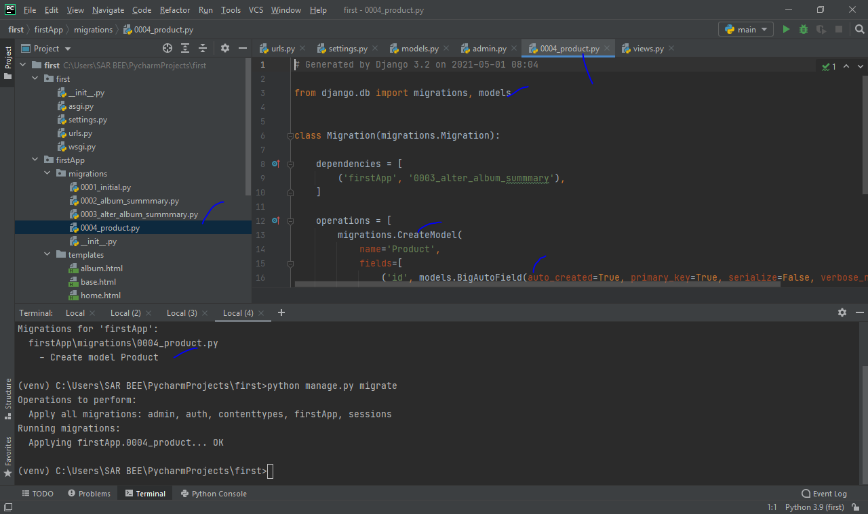
After doing this head on to the python terminal and save the model you create in the user interface admin space provided by django. So you type python manage.py makemigrations after that python manage.py migrate. You will see some result telling you that some migrations have been made see below
When you check the migrations folder you will see some product.py database created. And when you open it you will see some codes that created the database. So head on to django and type slash admin you should see your product app been
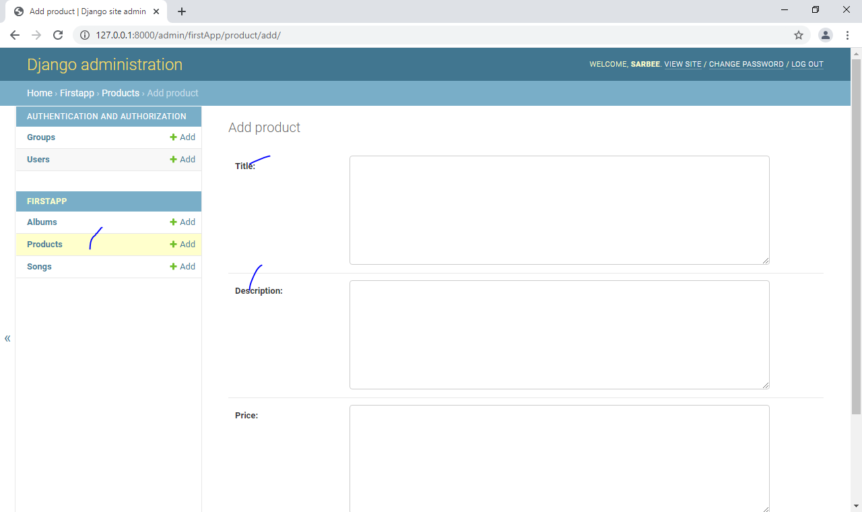
created. See below

You can see there is products app and table of title, description and price created.
Whenever we make changes to our model.py we should always run the python makemigrations and python manage.py migrate

Lets assume I want to add the summary table to my database. Then I will head on to the models.py and create a table of summary see below.
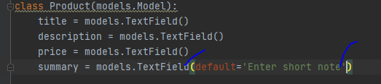

After doing this I will run the makemigrations and migrate as usual. The default=”enter short note” means that will be what will display in the table of summary in your app. Just like placeholder function in signup or register in html see the result below
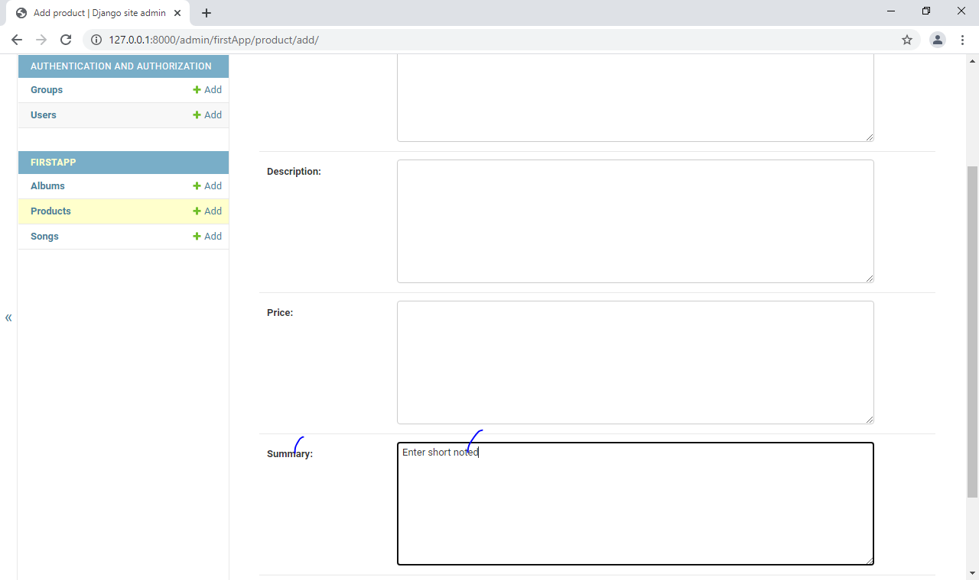

You can now fill the data you need in your table and it will be save in the database.

This model we created is not the best. Because everything is textfield which should not be like that. Price should be decimal. The title is too big we just need some little junk of words. So using textfield is not ideal. So lets make changes to this

To do this we can delete all the content in the migrations folder for the product and create a new one.
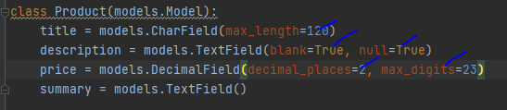

This is telling us that lets the title have a character of maximum length of 120, the description blank=True means we can skip it without adding any data. The price contain how many decimal places you want and the number of digits that should be there.
See result below
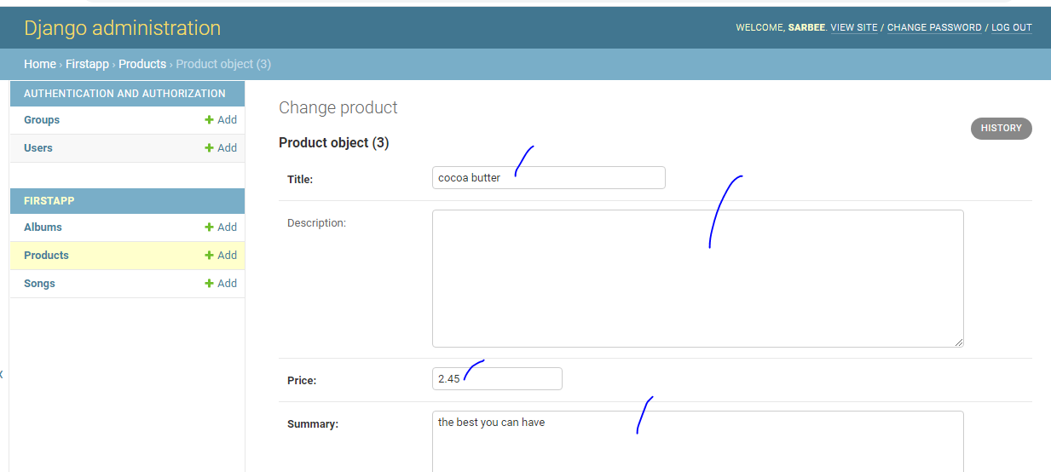
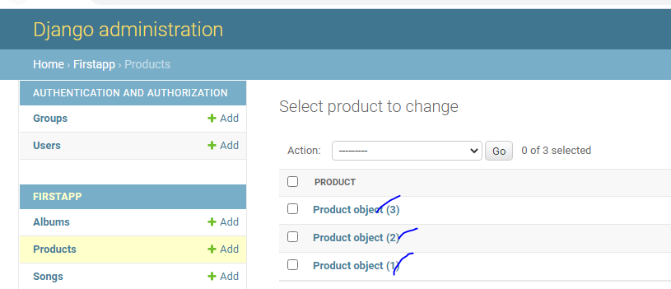
zwhen you register a product the name of the file in it doesn’t display unless you click on it. see what I meant below
we can actually fix this by displaying what we want to show in our app. So we create a class in the admin.py for this. That is the code below
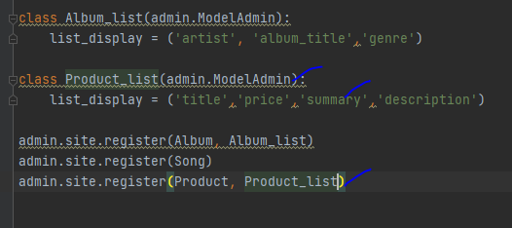

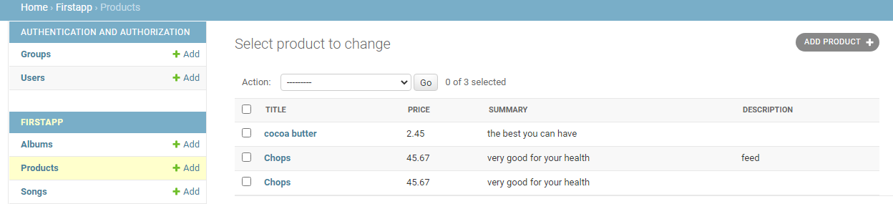
See the result
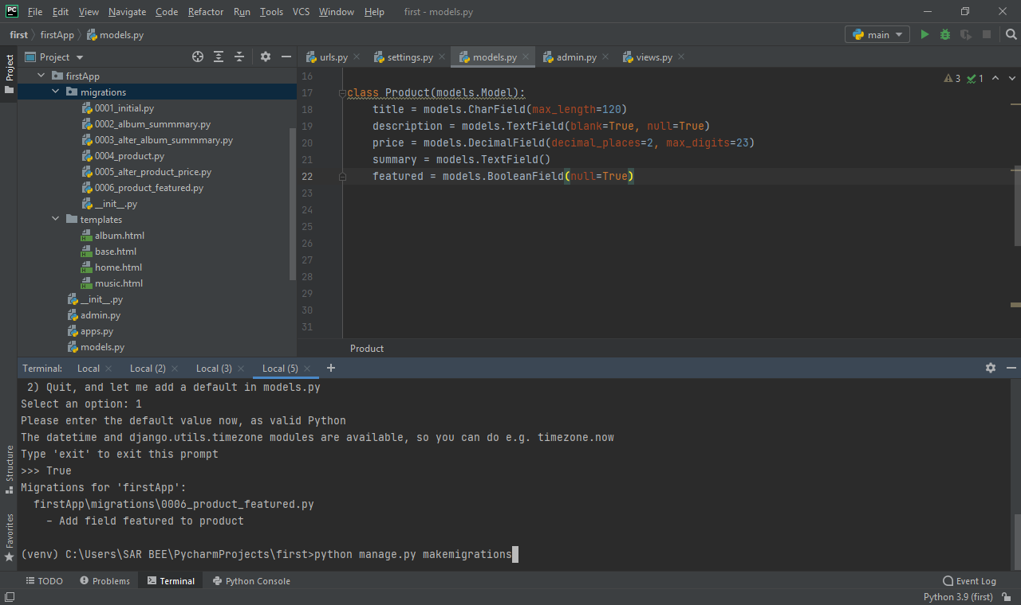
Let assume I want to add another table of BooleanField i.e true or false to my Product app and the ones I created earlier has to inherit the Boolean field . so how do I go about it. first lets create the table.
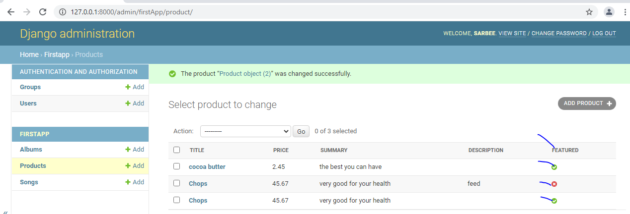
In the booleanField set the null to be true if not it will not run. Then the shell will request for some data to make changes to your new created table. Press 1 enter then True to make the changes. After that python manage.py makemigrations python manage.py migrate see the result
The one marked red mean “no” featured. Remember to add your featured table to the Product_list in the admin.py for it to display. What you see is that all our previous table that featured was not added has now add featured column

Extending other html page in an another file to other file using the base.html
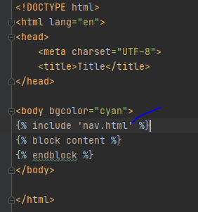

This will include what is inside the nav.html in any file that will extend the base.html file on. Lets look at what is in the nav.html
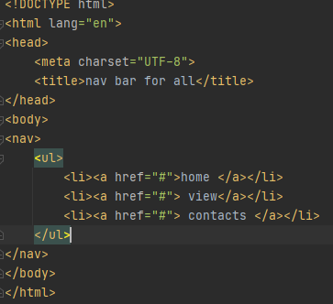

If we navigate to /music we should see something like this.
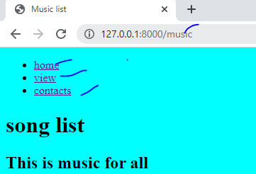

This is the earlier code on music.html which we extends the base.html
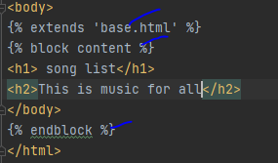

RENDERING CONTEXT IN AN HTML PAGE
We can use a dictionary to display the content of what we put in the views.py of a particular page for it to be display on the main page in the html. Let take for instance the album page
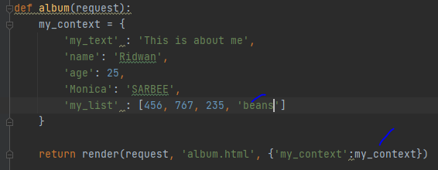

When we display the my_context in the album page and we loop through it this should display all the dictionary keys.
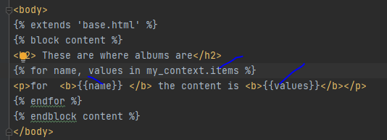

See the result
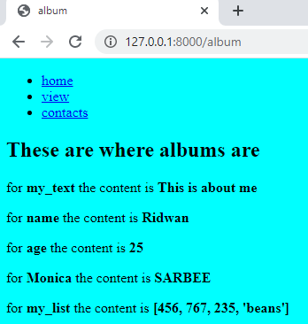

RENDERING DATA FROM THE DATABASE
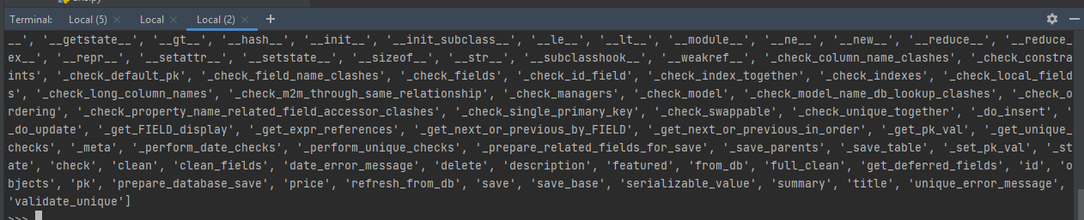
First lets use our django shell to see some amazing things. First you have to import the Product app you build from the base app which is firstApp. From firstApp.models import Product. This is telling us that we should import the Product app from our app. Note we can have different types of app in our model.py. next we can see the first data in the app. Product.objects.get(id=1). That is we want to see the first table. We can also make this an variable and check all the whole attributes or methods of our Product app. Obj = Product.objects.get(id=1) next we see all the directories and its function. dir(obj)
To get the title of the id 1 will be obj.title
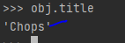

USING OUR PRODUCT APP ON OUR PAGE
We create a function of product_detail and make the objects_id 1 as a variable so that we can render what is inside in our details.html. we will also create a detail.html page in our templates folder so that we can display our result in it.

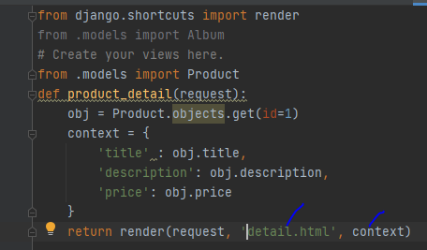

The code in the detail.html. we inherit the properties of the base.html
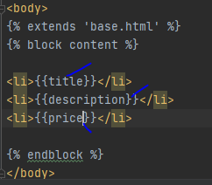

Next is to map our function product_detail to our urls.py

See the result
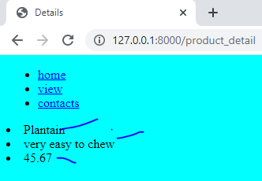

So the title of the product id 1 is Plantain, the description is very easy to chew and the price is 45.67

These method above is not efficient. Because if I want make changes to my Product in model.py, lets assume add another field I have to put the field among the dictionary object. So the best way to go about this is creating a variable for the obj which we already have a key Product.objects.get(id=1) then we use it in our detail.html file see below for clarification
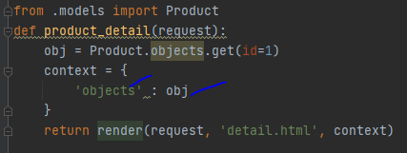

So in this we don’t need to start defining values for each key. Look at how to use it in detail.html
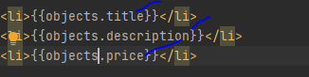

See the result
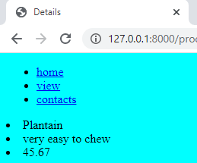

DJANGO MODEL FORM(using html page to create a database form with respect to the exact same thing in the admin)

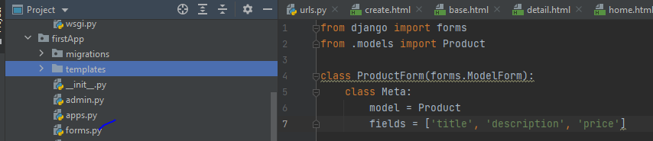
First create a new python file in your firstApp and name it forms
First we import the method forms that allows us to create form. We also import our product app that has all the features of form we want to create. Then we create a class of Productform which inherit a method known as forms.Modelform. we use the class Meta to list what we want to be in our field of form that we will field. Remember we are to use the model product because it has all this field from the admin

Next is to create our function in our view.py
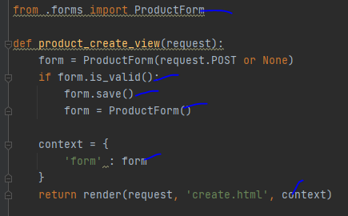

First we import the productForm class we created so that we can use the features in the view.py next we create a product_create_view function which we will map on our url web address. Next we create a variable form and we assign the method ProductForm to it we also set the security to request.Post or None so that people will not see sensitive information on our form in our address bar. Next we use the if condition to check if all the details have been entered, details like title, description and price, if all this is entered than we save our form and clear it so that we can add another field. (form.save() and form = ProductForm()
Next is to save our form in a context dictionary which we will use in our create.html to display the content of our form as in the GUI

We need to map our functions to our urls.py

Next we create an html page create.html which we will use to display the content of our form and save it to the database
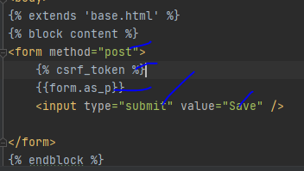

The form method will be post as usual because we don’t want people to see our sensitive details also for secured form of input from user either registration or login we use the security text django provide for us which is csrf_token. We display the form as form.as_p which means render the form in form of paragraph. . then our input type will be submit which will have the value i.e text replace with save see the result below
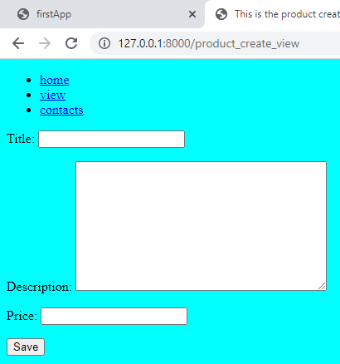

PURE DJANGO FORM

The above production of form is not the best way. The best way is to use the formfield features in our form.py. head to your forms.py and type the characteristics of your form see below:
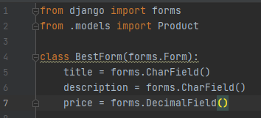

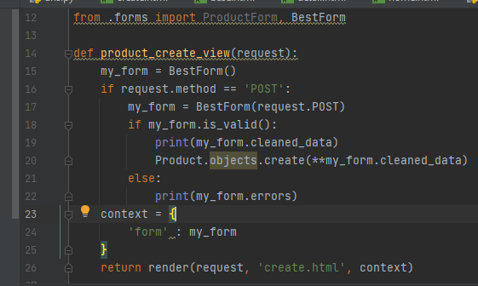
Next go to your views.py and import the class BestForm and define a function to display the result. We are going to use the earlier function

We created an instance of the form and save it in a variable my_form. We also save this in the form variable under the dictionary context so that we can use it in our create.html page. So in the html page we will make some little changes

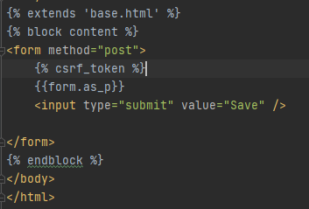

See the result
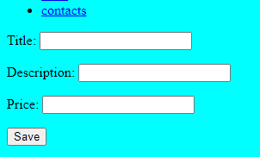

FORM WIDGETS
Giving our form a condition to be met before it submits a data

In the form.py you can add some data to the empty bracket to make it dynamic example
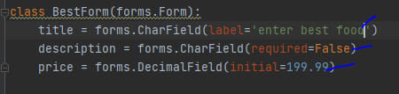

The title will be changed from title to enter best food. The description can be left empty since you set it as false. The initial price you will see on the price label is 199.99 see the result below
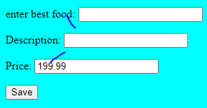

To make the title not to show anything as label we set the label to empty string like label=’’ ”
We can also override the features to anything we want. Like the description can be changed from character field to text area and also put a placeholder on each of them.
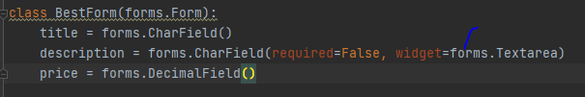

See the result
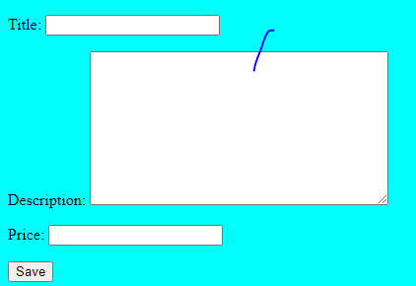

If I want to override lots of things in the description model which was initially set to character field. Then I have to put them in a dictionary. See below
This will make the row long and the column that is vertical section of our description wide. See the result
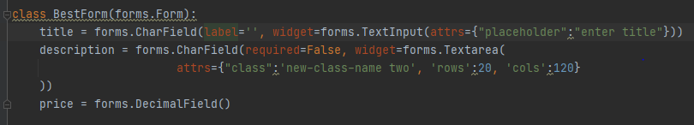
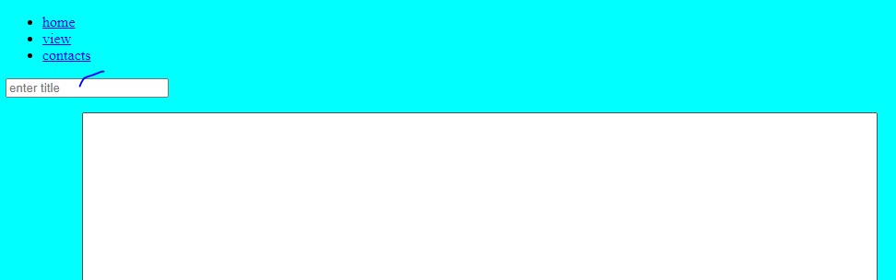
See the result. You can see the title tag now have a place holder enter title

You can also add the placeholder in the description label

